Exception Handling

# Basic Exception Handling

* An **exception** is an event that occurs during the execution of a program that disrupts the normal flow of instructions.
* **Exception handling** is the process used to change the normal flow of code execution if a specified exception occurs.
* Exceptions that occur during compilation are called **checked exceptions**.

|  |  |
| --- | --- |
| **Exception** | **Description** |
| ClassNotFoundException | The class is not found. |
| IllegalAccessException | Access to a class is denied. |
| InstantiationException | Attempt to create an object of an abstract class or an interface. |
| NoSuchMethodException | A requested method does not exist. |

* **Unchecked exceptions** are exceptions that occur during execution. These are also known as **runtime exceptions**.

|  |  |
| --- | --- |
| **Exception** | **Description** |
| ArithmeticException | Arithmetic error, such as an integer divided by 0 |
| ArrayIndexOutOfBoundsException | Accessing an invalid index of the array |
| ArrayStoreException | Assigning a value to an array index that does not match  the expected data type |
| InputMismatchException | Entering a value that does not match the expected data  type |
| NullPointerException | Invalid use of a null reference |
| NumberFormatException | Invalid conversion of a string to a numeric format |
| StringIndexOutOfBoundsException | Accessing an invalid index (character) of a string |

***try, catch,* and *finally***

* A ***try* block** is a block of code that might throw an exception that can be handled by a matching *catch*

block.

* 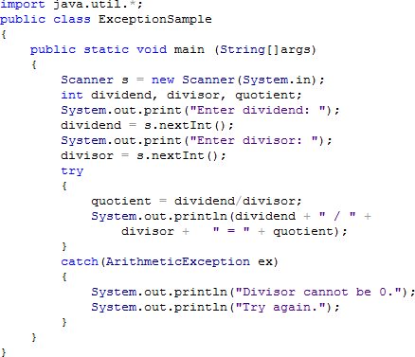A ***catch* block** is a segment of code that can handle an exception that might be thrown by the *try* block that precedes it.
* The ***getMessage()*** method can be used to determine Java’s message about the exception. Syntax: **System.out.println(exceptionName.getMessage());**
* 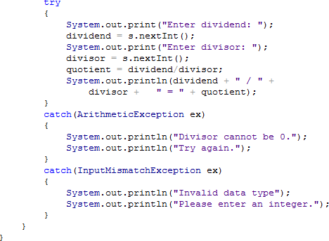Only one (1) *try* block is accepted in a program but there can be multiple *catch* blocks.
* A user-defined exception is created by extending the *Exception* class.
* 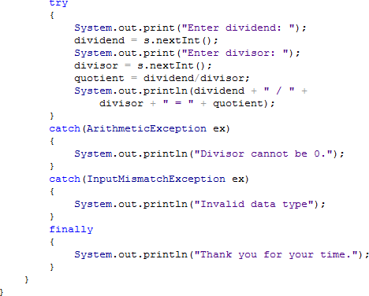The ***finally* block** contains statements which are executed whether or not an exception is thrown. There can only be one (1) *finally* block after a *try-catch* structure but it is not required.

# User-Defined Exceptions

* A **user-defined exception** is created by extending the *Exception* class.

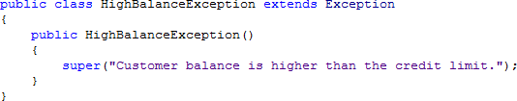

* 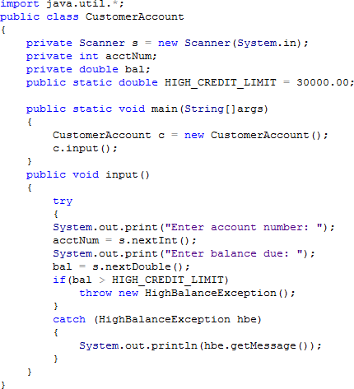A **throw statement** sends an exception out of a block or a method so it can be handled elsewhere.

Output:

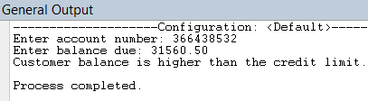

# References:

Baesens, B., Backiel, A. & Broucke, S. (2015). *Beginning java programming: The object-oriented approach*.

Indiana: John Wiley & Sons, Inc.

Farrell, J. (2014). *Java programming, 7th edition*. Boston: Course Technology, Cengage Learning

Savitch, W. (2014). *Java: An introduction to problem solving and programming, 7th edition*. California: Pearson Education, Inc.